SQL Table Creation Script – Seller and Inventory Management

Objective
The objective of this submission is to create the Seller and Inventory tables in the existing ShopEaseDB database and establish the required relationships with the Product table.

Select Existing Database
USE ShopEaseDB;

Seller Table Creation – Updated
The Seller table stores the details of sellers who supply products to the online store.
CREATE TABLE Seller (
Seller_ID INT PRIMARY KEY AUTO_INCREMENT,
Seller_Name VARCHAR(100) NOT NULL,
Phone VARCHAR(15) UNIQUE,
Email VARCHAR(100) UNIQUE,
Address VARCHAR(200)
);

Inventory Table Creation – Updated
The Inventory table stores product stock information and connects each Product with its Seller.
CREATE TABLE Inventory (
Inventory_ID INT PRIMARY KEY AUTO_INCREMENT,
Product_ID INT NOT NULL,
Seller_ID INT NOT NULL,
Quantity INT NOT NULL DEFAULT 0 CHECK (Quantity >= 0),
Last_Updated DATE NOT NULL,
FOREIGN KEY (Product_ID) REFERENCES Product(Product_ID),
FOREIGN KEY (Seller_ID) REFERENCES Seller(Seller_ID)
);

Constraints Used
Constraint | Purpose
PRIMARY KEY | Uniquely identifies each seller or inventory record
FOREIGN KEY | Connects Inventory with Product and Seller
NOT NULL | Ensures required fields are not left empty
UNIQUE | Prevents duplicate seller phone numbers and email addresses
CHECK | Ensures inventory quantity is zero or greater
AUTO_INCREMENT | Automatically generates unique IDs
DEFAULT | Sets the starting inventory quantity as 0

Verification
SHOW TABLES;
DESC Seller;
DESC Inventory;
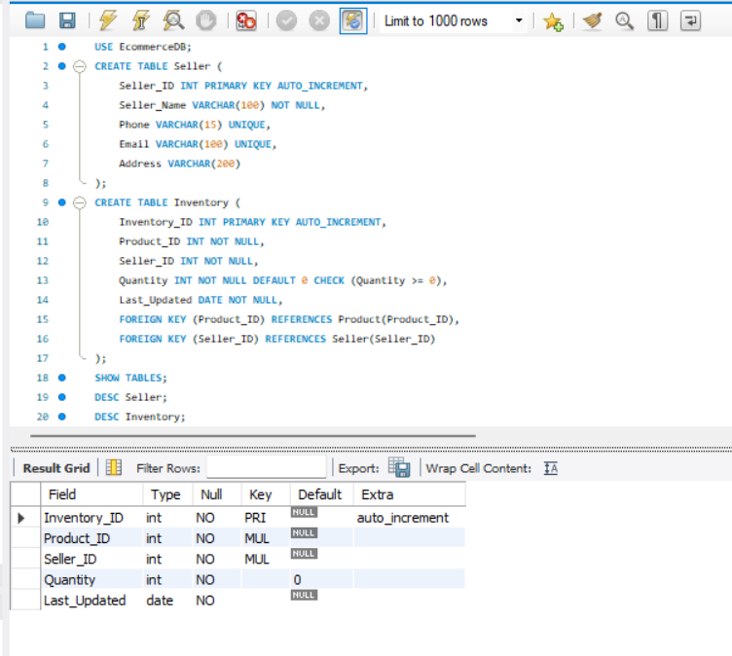Result
The Seller and Inventory tables were successfully created in the ShopEaseDB database. Foreign keys connect Inventory with Product and Seller.

